## Appendix E - Overview of Bleik and HQ

Figure E 1 gives a bird eye view Bleik community house (‘HQ’) and the close surrounding areas, with the areas intended use indicated. E.g. where to park test vehicles when used in a test (in front of the HQ) and where to place antennas (in front of and ENE of HQ).

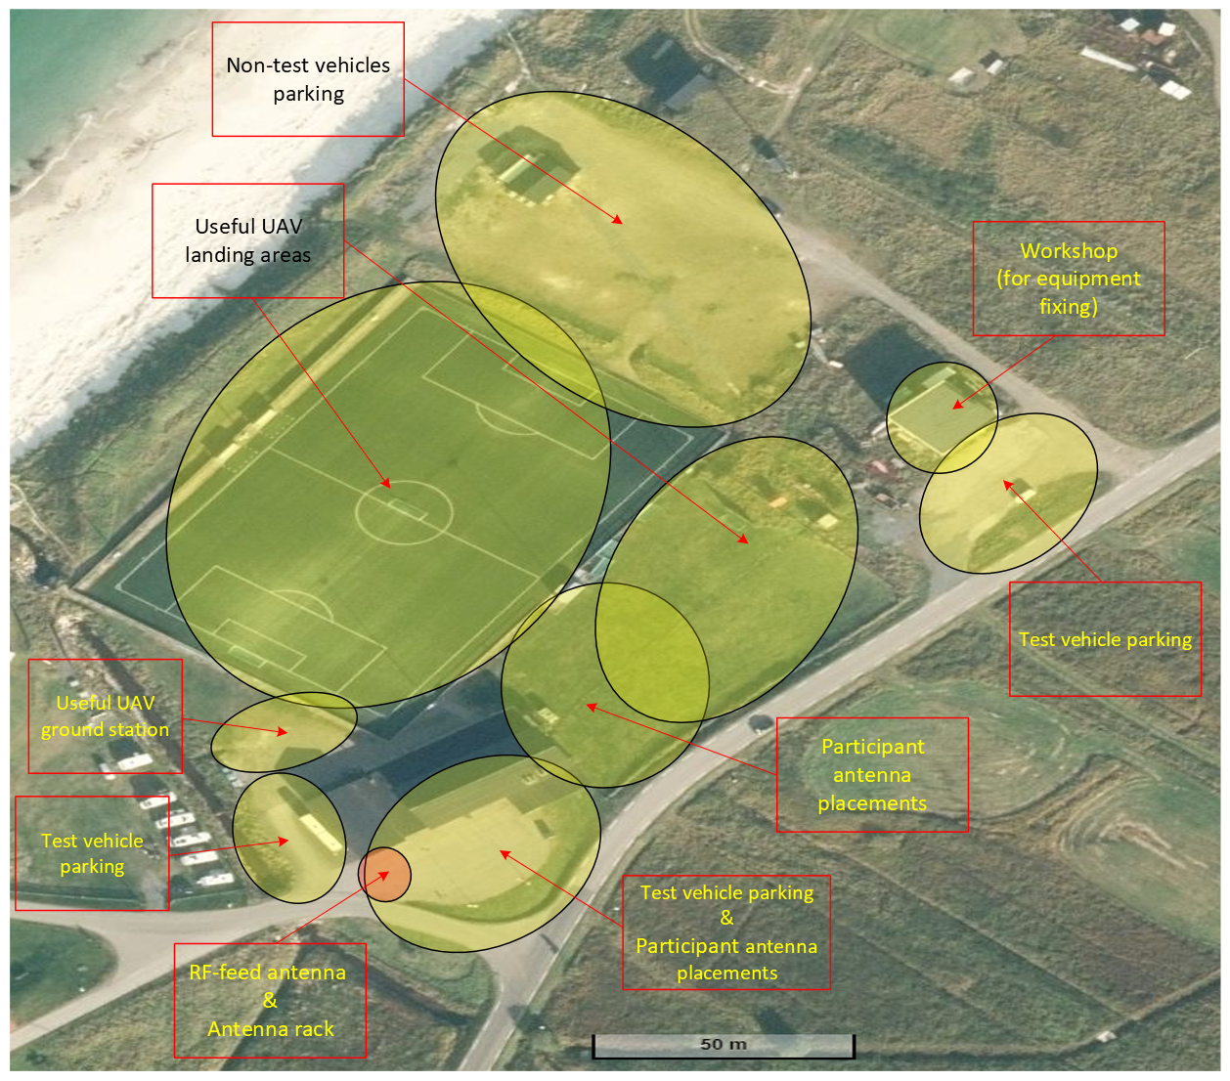Note that parking is strictly enforced. Note also that indications of where to set up antennas and where to land/control UAVs are suggestive.

E 1: Bleik community house (‘HQ’) and the close surrounding areas, with intended use indicated. Aerial photo from norgeskart.no

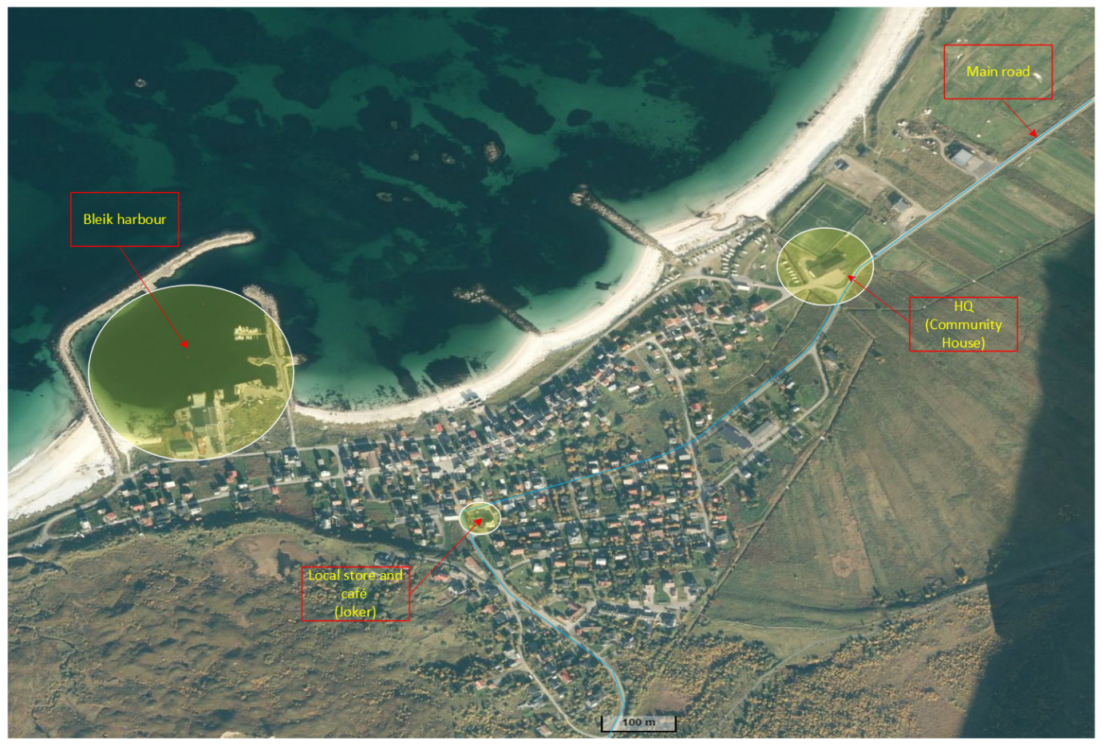Figure E 2 gives a bird eye view of the village of Bleik with important locations indicated.

E 2: The village of Bleik and the surrounding areas, with useful locations indicated. Aerial photo from norgeskart.no

Figure E 3 and E 4 shows the areas from figures E 1 and E 2, respectively, without indications.

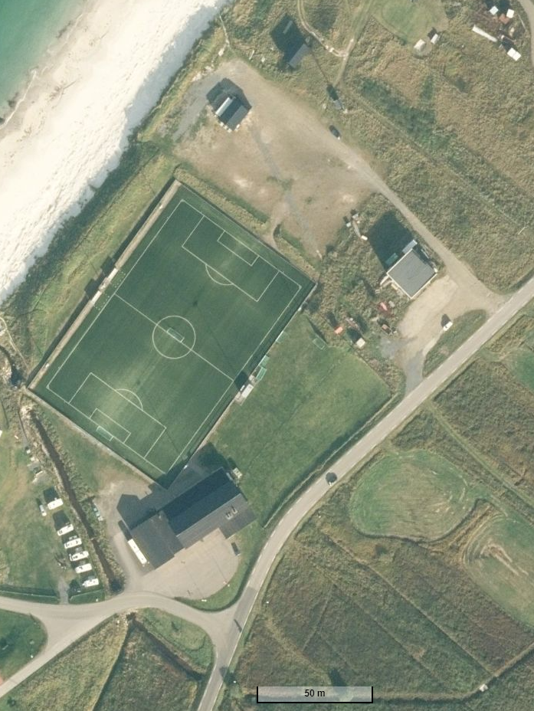

E 3: Overview of Bleik HQ and close surrounding areas. Aerial photo from norgeskart.no

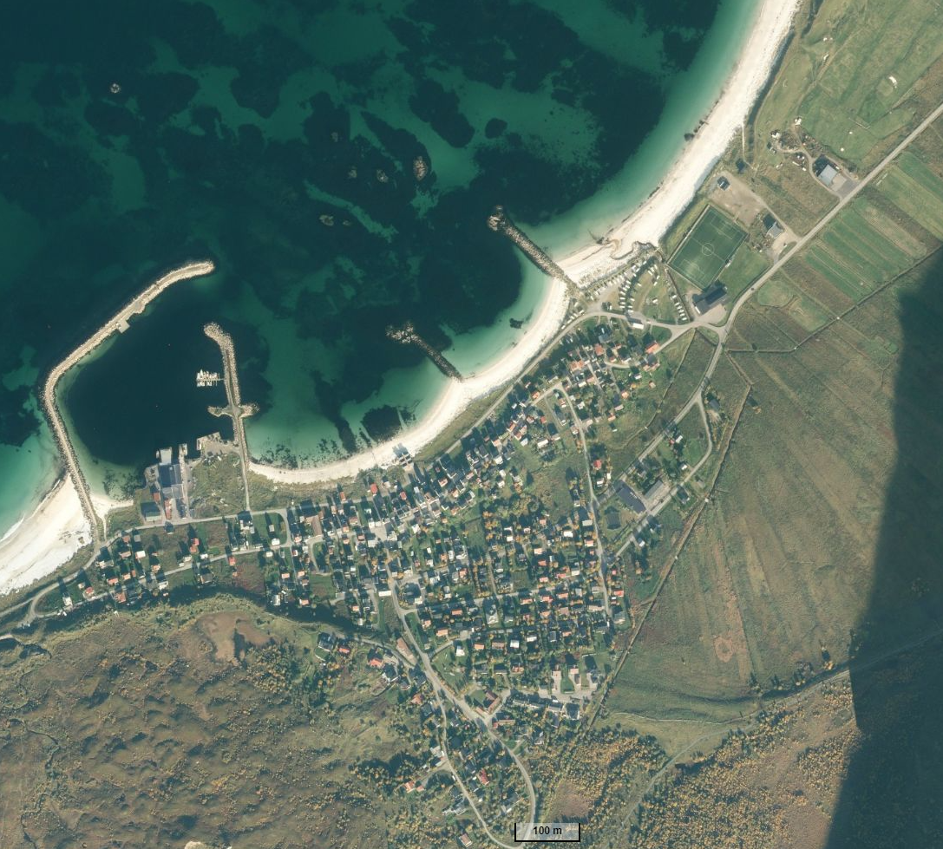

E 4: Overview of Bleik village and surrounding areas. Aerial photo from norgeskart.no